

wede5020 – poe -part 1

ST10284733 Pranay Stanley Appanna



Table of Contents

Website Choice: 2

Website Pages: 3

Website Assets: 4

Reference List: 5

# Website Choice:

The Go Green Initiative, the reason why I chose this topic, is because it will focus on all types of pollution, which include air, water, etc. Why have I said I will focus on all types of pollution is because I think that there aren’t enough NGO’s doing the same thing as I have, they mostly focus on one thing. I just feel as if they aren’t doing what I think they should be doing focusing on every aspect to help save our earth. Our main goal is to save the earth from all these bad habits and it’s our goal to stop it. Most people have organisations for this which are devoted to helping these causes, but mine is primarily focused on everything and anything. Green energy is the way to go because, many people believe that going green isn’t the right way because it’s too expensive and not many people can afford it. But I see going Green as an efficient way for everyone, because it’ll reduce costs on living and people. Now how do I get this organisation up and running, how will this happen, well you bring all recycled goods at any pop –up market place, you trade in your goods and in return get back R1, which will then go towards the funding of the organisation. This initiative will be a global organisation because once I turn it global my NGO, I’ll be recognised and then funding will become easier for me. The reason why the “Go Green Initiative” is focused on all types of pollution is to also help other small NGO’s that are up and coming, to offer them help and bring them into our organisation and make them independent, meaning that we will help grow these NGO’s and put them under our sponsorship.

There’s also a variety of different things that will be available to the website, such as vehicle ideas, contact information, if you’d like to join and an up-coming tab. These 4 different tabs, are vital for the website itself, because they play an important role in the information. This also entails what we mainly focus on in our NGO.

# Website Pages:

About us – What we entail to do for the NGO and our goal

Up- Coming Products – Details, on what is going to be included in the NGO itself and what are some of the project ideas we have.

Contact Information – You’ll put your number, name and surname and, to tell us if you are going to join our NGO. We also entail that we will sponsor you, the advocate.

Gallery – this is where you’ll see a little information on what we are going to provide.

And the index page, will show the navigation for the 4 other tabs, that will be discussed.

Casting, the information will be and can be available on other devise so that the NGO will be able to those with different devices.

# Website Assets:



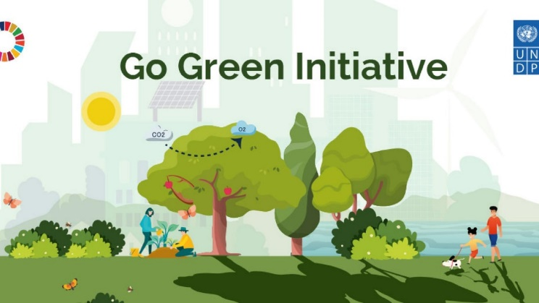



What the LOGO is toughly like and the slogan:

Go Green or Go Home – Slogan

Idea of Logo -



Which site to use for the logo and slogan:

Looka.com

# 

# Reference List:

<https://www.undp.org/bosnia-herzegovina/news/undps-go-green-initiative>

<https://www.conserve-energy-future.com/21-good-reasons-to-go-green.php>

<https://gifdb.com/gif/sage-green-recycle-bin-miv4dnagiz3u4wi1.html>

<https://www.google.com/url?sa=i&url=https%3A%2F%2Fwww.papertraildesign.com%2Fcircle-banner-letters%2F&psig=AOvVaw0g3ftYR0dtPfZd4epzFcy1&ust=1685459287186000&source=images&cd=vfe&ved=0CBEQjRxqFwoTCLiJzqTnmv8CFQAAAAAdAAAAABAP>

<https://www.google.com/url?sa=i&url=https%3A%2F%2Fblueandgreentomorrow.com%2Fenergy%2Fgo-green-with-electric-car-tight-budget%2F&psig=AOvVaw1BV3bYZHolUQLiFsQ8q7K5&ust=1685455123537000&source=images&cd=vfe&ved=0CBEQjRxqFwoTCKCjleXXmv8CFQAAAAAdAAAAABAW>